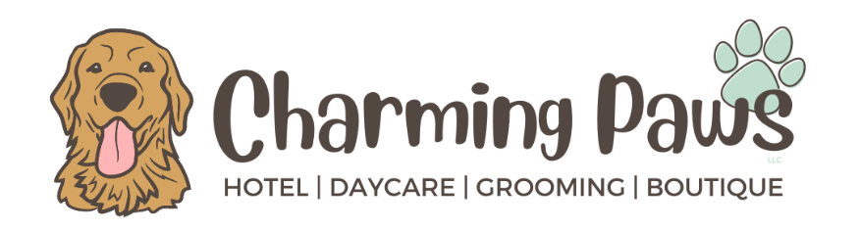
Grooming Intake Form
Owner’s Information:
First and Last Name: _____________________________________________________________
Address: ______________________________________________________________________
City: ________________________ State: ____________ Zip Code: ____________________
Best Contact Number: ___________________________________________________________
Additional Number: _____________________________________________________________
Emergency Contact Person & Phone Number: ________________________________________
Email Address: _________________________________________________________________

Pet’s Information:
Name: _____________________________________ Breed: ____________________________________
Age: ________________ Sex: ____________ Color: __________________ Weight: _________________
Allergies: _____________________________________________________________________________
Has you dog ever been to a groomer/grooming facility before? [ ] Y [ ] N
Does your dog get stressed easily? [ ] Y [ ] N
Does your dog have any underlying health conditions that you are aware of? [ ] Y [ ] N
Is your dog spayed/neutered? [ ] Y [ ] N

Veterinarian Information:
Clinic: ______________________________________ Name: ___________________________________

Shall my pet be injured or need medical attention while undergoing any sort of grooming service at Charming Paws LLC, I approve $__________ in medical treatments in the event Charming Paws LLC or its employees are unable to obtain contact with me.

At Charming Paws, we take the safety of the pups in our care as our top priority. We will do everything we can to ensure your pup is in the best care possible. We also feel that education is important in providing our customers peace of mind and as owner, _______________________________, you understand the inherent risks of grooming. Risks can include small injury due to grooming clippers/scissors, stress related injury, allergic reaction to shampoo, etc. We will always be transparent regarding anything that we may notice while your pet is under our care and ask that you please share anything that may help us.
_________________________________________________ ___________________
Signature of Owner or Owner’s Representative Date

