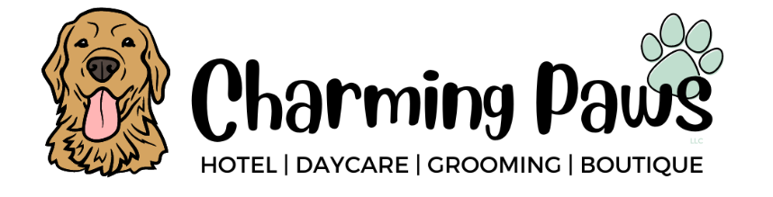

1-on-1 Activities
($15 per 15 minutes)
Bubble Time
- Bubble time is an activity where dogs chase and catch flavored bubbles. Bubbles can be an enriching game for dogs that can keep them mentally and physically agile. The activity can stimulate a dog's mind, requiring quick thinking and fast reaction times!
Nature Walk
- A 15-minute nature walk through our trails is a great enrichment activity for your pup that will offer new sights and smells that haven't interacted with before. It is also a great way to get some much-needed exercise and helps your pup get some fresh air while enjoying the beauty of Mother Nature and feeling the breeze through their fur!
Pool Time
- Swimming is an awesome opportunity to introduce a new stimulus to your pup! In a pool, they have access to a range of activities that aren't possible on land such as bobbing for toys, submerging their bodies below water, and splashing!
Pupsicle
- The Pupsicle is the best dog treat dispensing puzzle toy on the market. The Pupsicle is dishwasher safe for easy cleaning, long-lasting, and is safer than any bone you could give your pup! Pupsicle treats will typically last 20-40 minutes but we make sure you get the most bang for your buck by freezing the treats, so your pup gets an extra-long treat sesh!
Snuffle Mat
- A snuffle mat is an interactive feeding mat and scent game for dogs that involves hiding treats in the mat's fabric. The mat is often made of fleece strips attached to a plastic or rubber base with holes for hiding treats. The treats encourage the dog to use its sense of smell and natural hunting instincts to "hunt" and forage for them.
Treat Puzzles
- A treat puzzle activity is a toy that contains holes on the sides and food/treats inside that your dog can "work" for a reward. Puzzle toys range from levels "easy" to "hard" and can provide mental stimulation along with helping to reduce stress and anxiety for dogs.

