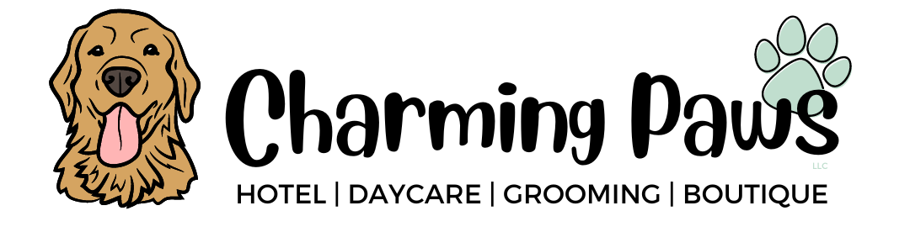

Daycare Pricing
Individual half day (Less than 5 hours)
- $24 per dog
**No discounts offered for multi-pet families attending daycare for half days
Individual full day (Over 5 hours)
- $32 for 1 day for 1 dog
- $60 for 1 day for 2 dogs
**Any dog after the 2nd follows 2nd dog’s pricing.
Family Packages

- $138 for 6 half days
- $276 for 12 half days
- $552 for 24 half days
- $186 for 6 full days
- $360 for 12 full days
- $696 for 24 full days

Boarding Pricing
- $44 per 24-hours for 1 dog
- $78 per 24 hours for 2 dogs
- $107 per 24 hours for 3 dogs

** First night deposit is required at the time of booking to secure your spot.
** Additional late checkout fee of $10 per dog charged if dog(s) are not picked up by 24-hour mark on the day they are scheduled to go home.
EX: If dropped off at 10AM on arrival date, they must be picked up before OR at 10AM to not receive the $10 late fee

ALL boarding deposits are NON-REFUNDABLE and NON- TRANSFERABLE.
To stay small, provide private suites, and an unmatched level of care and attention to all our pup guests, we do require a one-night deposit that will come off your bill at the end of your stay. We ask that you please book when your plans are concrete so we can accommodate as many friends as we can, while still providing the same level of service.

